**Group Members**

**Jeffrey Takyi-Yeboah**

**Efua Bainson**

**Maame Yaa Poku**

**Constant Likudie**

**Nana Kwadwo Darfoor**

**Final Report**

Our project was targeted at investigating the manifestos of political parties taking part in this year’s election process. The parties in question include New Patriotic Party, National Democratic Congress, Convention’s People Party and the Progressive People’s Party. The whole point of the project was to discover the common words used in each manifesto as well as all the manifestos combined. We also compared the manifestos of the top two parties and bottom two parties to find what they said in common. At the end of the day, our aim was to gain insights and draw conclusions as to what the parties had in common in terms of strategies, plans or words they used in their respective manifestos. We used a word cloud to represent these insights for the respective manifestos, as well as bar graphs to visualize the top ten common words in the manifestos. A frequency table also showed the number of times the top ten words were used in the manifestos. For each of the representation, that is, for the single manifesto, all manifestos and side-side manifestos (comparing two manifestos), we used the above method to represent the information.

**Insights**

Here are some of the findings we made after our analysis of the various manifesto:

**NDC Manifesto**

The top ten common words that were found in the NDC manifesto were “Will”, “Development”, “Ghana”, “National”, “Continue”,” Region”, “Support”,” Education”, “Sector” and “Production”. The table below shows the words along with their frequencies. From this list of words, we can get an idea of the message political party is trying to put across. For instance, the word “Continue” gives us an idea that there are a number of projects or programs the party would like to continue if they win the upcoming elections. Also, it is a word supports have been using these days ,“JM toaso”, where “toaso” means continue. Additionally, the words “Development”, “Education” and “Production” and “Support” gives us an impression of the plans the party has for the nation.

|  |  |
| --- | --- |
|  | word frequency |
|  | will will 206 |
|  | development development 149 |
|  | ghana ghana 136 |
|  | national national 121 |
|  | continue continue 119 |
|  | region region 116 |
|  | support support 103 |
|  | education education 99 |
|  | sector sector 87 |
|  | production production 77 |

**NPP Manifesto**

For this manifesto, the top ten words are, “will”, “NPP”, “new”, “development”, “government”, “party”, “patriotic”,” manifesto”, “election” and “sector”. It was surprising that two of the top words were “manifesto” and “NPP”. This means the party kept on referring to themselves and the manifesto itself. Additionally, they mentioned “election” even more than the NDC did and this shows how important this election is to the party. Again the use of the word “government” gives us an impressing that the party might be pointing out a lot of things the present government did or failed to do. Below is a table showing the ten common words along with their frequencies:

|  |  |
| --- | --- |
| WORD FREQUENCY | |
|  | will will 449 |
|  | npp npp 443 |
|  | new new 208 |
|  | development development 195 |
|  | government government 179 |
|  | party party 167 |
|  | patriotic patriotic 166 |
|  | manifesto manifesto 147 |
|  | election election 143 |
|  | sector sector 133 |

**CPP Manifesto**

In CPP’s manifesto, the top ten words were “will”, “development”, “cpp”, “policy”, “shall”, “national”, “sector”, “public”, “ensure” and “ghana”. CPP seems to focus more on education and increasing production. “Ghana”, “public” and “national” emphasizes more on the people as a group showing a sense of unity in this regard. The top ten words of CPP and NDC are similar with words such as “sector”, “national”, “development”, “Ghana” being the most dominant. This gives the impression that NDC and CPP are considering implementing similar policies. Between CPP and NPP, some of the words that showed similarity in terms of policies to some extent include “will”, “development” and “sector”.

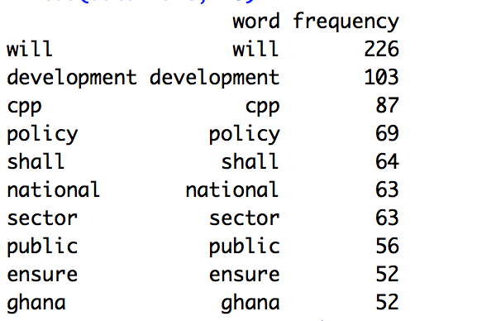

**PPP Manifesto**

The top ten common words that were found in the PPP manifesto were “Will”, “PPP” (no surprise there), “Ghana”, “Policy”, “People”,” Region”, “Party”,” Education”, “Progressive” and “Ensure”. The table below shows the words along with their frequencies. From this list of words, the word ‘ensure’ really stood out as one of the keywords. This gave a sense of promise to the people of Ghana with respect to the plans and commitments the party has if voted into power. “Education” seems to be the main focus of the party as it is the concept that appears the most.

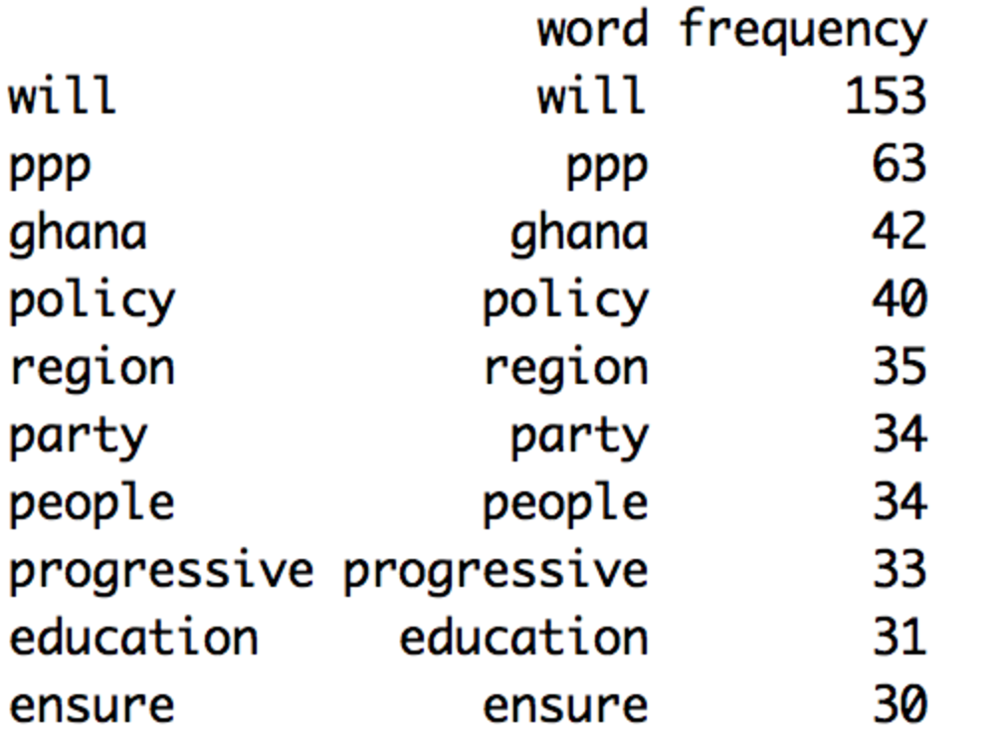

**NPP and NDC**

The top ten words for NPP and NDC are “will, “development”, “Ghana”, “government”, “sector”, “national”, “education”, “support”, “country” and “ensure”. “Will” is the most frequently used word. This gives the impression that NPP and NDC are making promises to Ghanaians about what they will do to make the standard of living better. Education stands out as a sector that both parties want to develop.

|  |  |
| --- | --- |
| word frequency | |
|  | will will 654 |
|  | development development 323 |
|  | ghana ghana 262 |
|  | government government 238 |
|  | sector sector 221 |
|  | national national 215 |
|  | education education 167 |
|  | support support 167 |
|  | country country 153 |
|  | ensure ensure 151 |

**All Manifestos**

All the political parties use “will”, “development”, “Ghana”, “government”, “sector”, “new”, “ensure”, “national”, “party” and “policy”. This gives an impression about the promises the political parties are making. “New” gives a sense of the ideas they are bringing on board to make Ghana a better place. Every party has policies they believe will bring growth.

|  |  |
| --- | --- |
| word frequency | |
|  | will will 1033 |
|  | development development 463 |
|  | ghana ghana 353 |
|  | government government 295 |
|  | sector sector 285 |
|  | new new 279 |
|  | ensure ensure 232 |
|  | national national 223 |
|  | party party 213 |
|  | policy policy 209 |

**Conclusion**

With regards to the manifestos from each political party, we drew certain conclusions that are relevant to the electorate in the upcoming election, concentrating on the plans and policies of the parties and how they were reflected in the manifestos.

For NDC, words such as “continue”, “will” and “development” were used. “Continue” emphasizes on their mantra for the election, “toaso”, which locally means continue. It meant that, a lot of existing policies and plans will be continued when they are given the mandate. A lot of promises were generally made as the word “will” was dominant in the manifesto. “Education” and “Production” policies were also evident in the manifesto showing the party’s interest in the former.

For NPP, the most dominant words were “will”, “new”, “development” and “npp”. As an opposition party, it is obvious how the party is more interested in creating new policies and strategies giving the impression that they are going to scrap the existing ones. This shows how dominant the word “new” is in the NPP manifesto.

Similarly, the CPP manifesto made use of “will” indicating a lot of promises. Their manifesto also highlighted a lot about development policies, as their core aim is to help the country develop.

Also the PPP’s manifesto, had a lot of dominant words such as “will”, “progressive” and “education”. “will” shows the incidence of a lot of promises throughout the manifesto. The use of “progressive” throughout the manifesto relates to the party’s name, progressive people’s party and that was also highlighted in their plans for progression.

Comparing NPP and NDC showed rather fascinating insights. Both parties made a lot of promises in terms of what they seek to implement when given the mandate and this was evident in the word, “will” which was dominant in both manifestos.

“Development” was also used a lot in the manifestos indicating the policies that were targeted at helping the country develop. Also, another significant similarity is the use of “education” in both manifestos showing an interest or initiative to work on the education when they come into power.

Finally, all the manifestos had similar words such as “will”, “development” and “Ghana”. In essence, this explained the consistent promises(“will”) and development policies that all parties seek to implement for country, Ghana. This describes why the words ‘will’, ‘development’ and ‘Ghana’ were the most dominant words throughout the manifestos.